1. Through TestNG.xml

Just right click the project and say RunAs 🡪 testNG.suite

1. Through pom.xml

To run the test cases using pom.xml, we should add the following plugins under build tag

1. Maven-compiler (<https://maven.apache.org/plugins/maven-compiler-plugin/examples/set-compiler-source-and-target.html>)
2. Maven-surefire like (<https://maven.apache.org/surefire/maven-surefire-plugin/usage.html>)

<build>

<pluginManagement>

<plugins>

<plugin>

<groupId>org.apache.maven.plugins</groupId>

<artifactId>maven-compiler-plugin</artifactId>

</plugin>

<plugin>

<groupId>org.apache.maven.plugins</groupId>

<artifactId>maven-surefire-plugin</artifactId>

<version>2.8.1</version>

<configuration>

<suiteXmlFiles>

<suiteXmlFile>testng.xml</suiteXmlFile>

</suiteXmlFiles>

</configuration>

</plugin>

</plugins>

</pluginManagement>

</build>

1. Then right click on pom.xml and say RunAs🡪 MavenTest
2. To run the test cases through command prompt
3. Install the maven software and set the env variable.
4. Navigate to the project location and open the command prompt form there.
5. Type “mvn clean install” (without quotes) and press enter.
6. To run as a run.bat
7. Add “b” and “c” from point 3 in a notepad and save it as run.bat file and double click it.

Note: point b should be mentioned with cd at the beginning [root directory of project]

1. To run via Jenkins
2. Download the Jenkins war file and extract and run it using command prompt with java –jar jenikins.war
3. Open browser and say localhost:8080 and press enter to open Jenkins. Since by default jekins will take the local host
4. Complete the initial one time process like credentials creations and login (admin / Rumble@12) 🡪 Note: If you forgot your password use the following link “<https://www.devglan.com/online-tools/bcrypt-hash-generator>” and use the hashed password from C:\Users\M1030042\.jenkins\users\admin_5989254161458711088\Config file under “<passwordHash>#” tag. Then type your password and check they are matching.

**For Jk tech – user name is – raghavdce and password is usual one**

**For admin the pwd is -** d234ab3fc0c547eabb9dbec617dcbc93

1. Once logged into Jenkins, click “New Item” and in the new item go to build dropdown and select using window bat file
2. Add

cd <project location>

run.bat

and save

1. Click build now to see the status
2. To configure the Jenkins to run at a particular time, use the “Source Code Management” tab 🡪 then “Build Triggers” sub-tab 🡪 “Build Periodcially” using 5 starts and each star position denotes the below
3. MINUTE (0-59), HOUR (0-23), DAY (1-31), MONTH (1-12), DAY OF THE WEEK (0-6)

**How to connect the code from GIT to Jenkins:**

**=========================================**

1. After started the Jenkins and launched the Jenkins in local host port, create a maven style project
2. Go to source code management tab and select “GIT” radio button and pass the GIT repo url

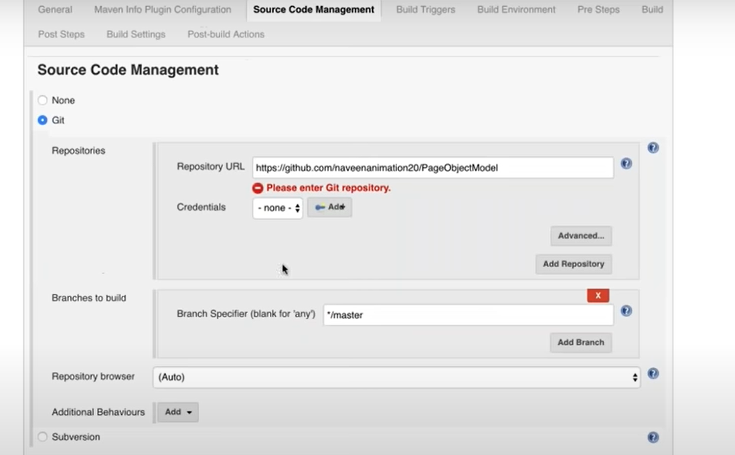

1. Rest of the options are same as above
2. Note: Build section where we mention the POM.xml path will have the value as pom.xml since we have given the root directory of the project from GIT and the pom.xml is in root folder
3. 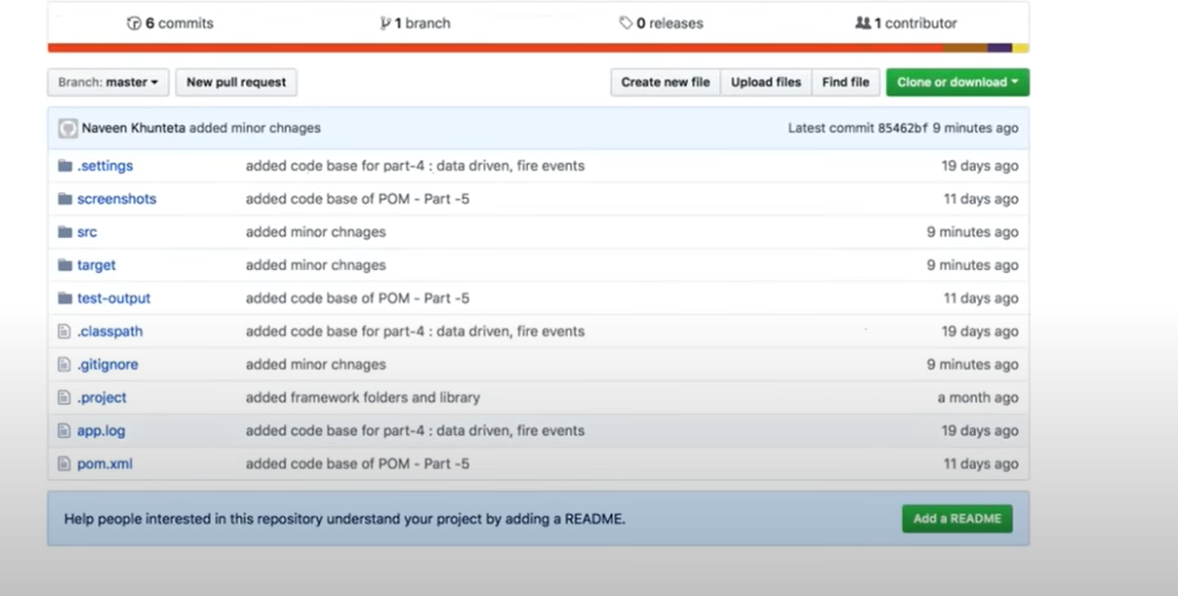
4. 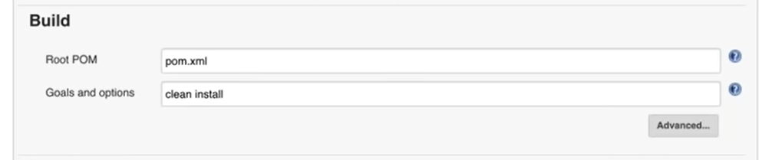
5. In post build section we can select Extent HTML report and do the following config

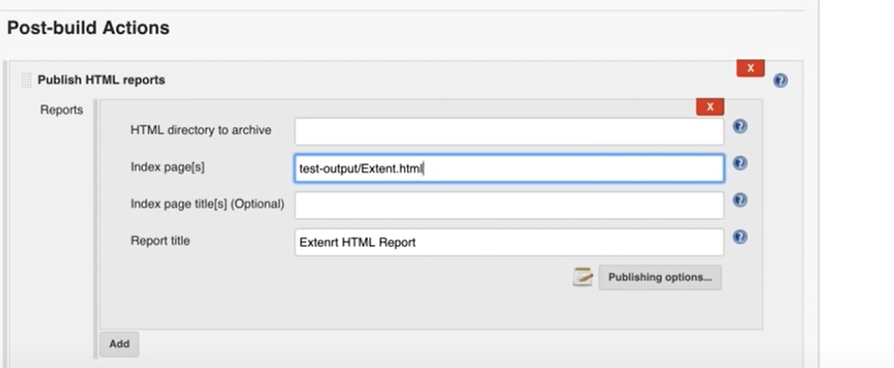

1. Also when the report is generated, starting from Jenkins 1.6, it is not showing the report in readable format and to overcome that we need to add a syste.setproperty in

Jenkins icon on top left🡪 manage Jenkins 🡪 Manage Nodes & Clouds 🡪 Setting (gear icon) script console on the left pane and add the below on the right hand side window

**System.setProperty(“hudson.model.DirectoryBrowserSupport.csp”,””)**🡪 Run

